**REACT JS MINI PROJECT (CAPSTONE PROJECT)**

**AUDIO DEVICE STORE**

**“ CASSETTES ”**

**Documentation**

**GROUP MEMBER DETAILS**

1. **CHATAK SHINDE - chshinde@deloitte.com**
2. **SAHIL BHAWANI - sbhawani@deloitte.com**
3. **KRISHNA KANT PHATE - kphate@deloitte.com**
4. **ATHARV UDAWANT - audawant@deloitte.com**
5. **YASH FULZELE - yfulzele@deloitte.com**

**Technologies To Be Used:**

HTML, CSS, JavaScript, Bootstrap, React.JS, Node, JSON Server, Redux, Axios, **(Deployment if possible).**

**Project Overview:**

This project works in the manner of a fully functional Audio-device-store app where we have certain features:

1. **Pages (With Routes):** Home page, About Page, Contact Page, Login Page, Registration Page, Products Page, Products By Category, CRUD Page, Shopping Cart Page, Final Order Page, Admin Page, Customer Page.
2. **Components:** Admin Component, Home Component, Browse Component, Store Component, Details Component, Cart Component, Login Component, Register Component, Checkout Component, Checkout Component.

**Modules Used:**

1. **Admin:** CRUD Process on Products, Admin Module is secured and we need to perform admin activities. Admin route should be secured**.**
2. **Customer:** View Products, View Products By Category, Add or Remove a product, see a product’s details, checkout.
3. **Shopping Cart Module:** Display all the products in cart, show grand total of all the products, customer can remove a product and when all the additions are done on the cart, customer can proceed for the checkout.

**APPLICATION SCREENSHOTS**

1. **SIGN-IN**

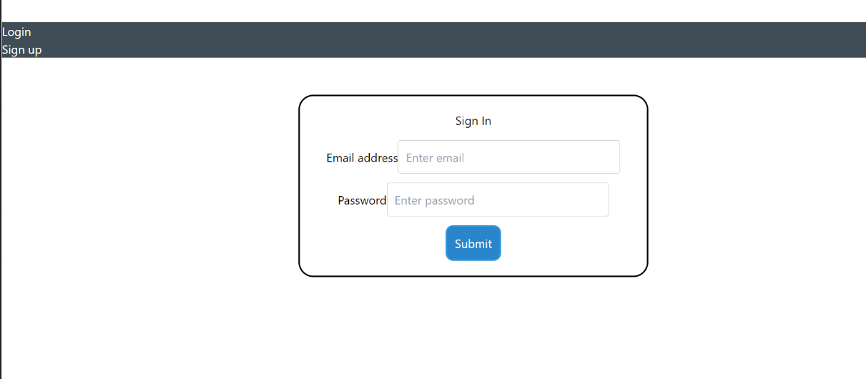

1. **SIGN-UP**

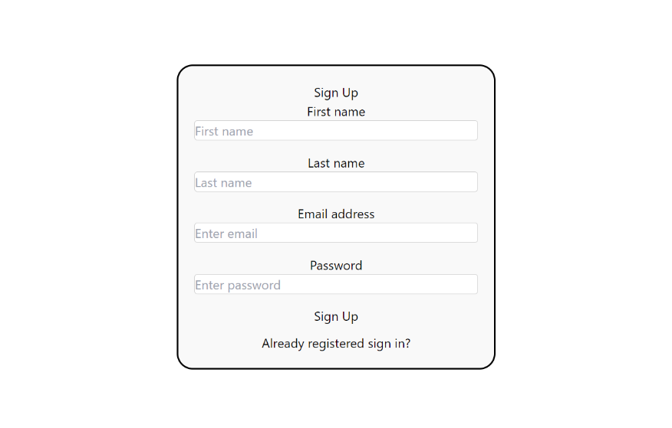

1. **HOMEPAGE**

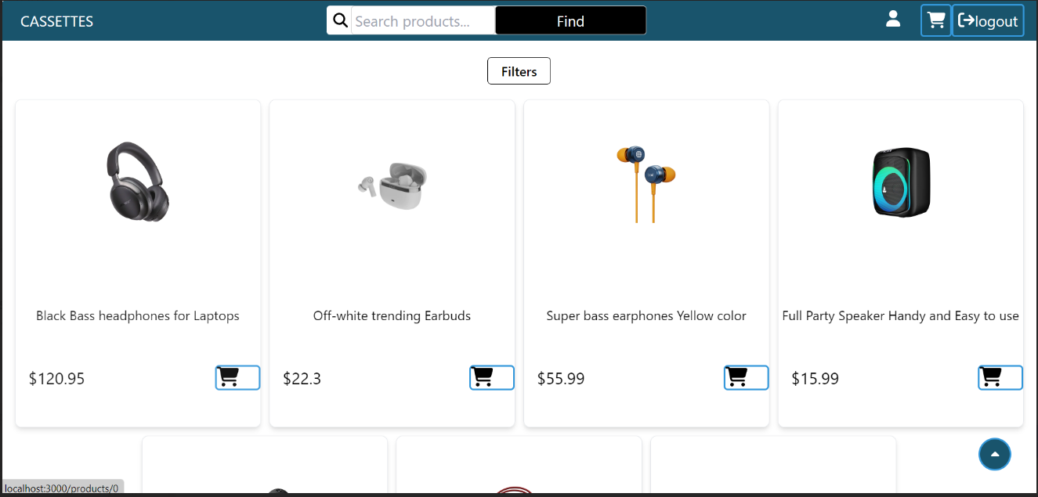

1. **PRODUCT SPECIFIC PAGE**

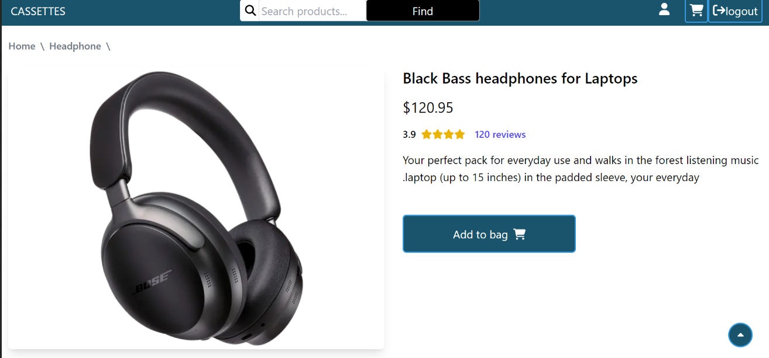

1. **CART**

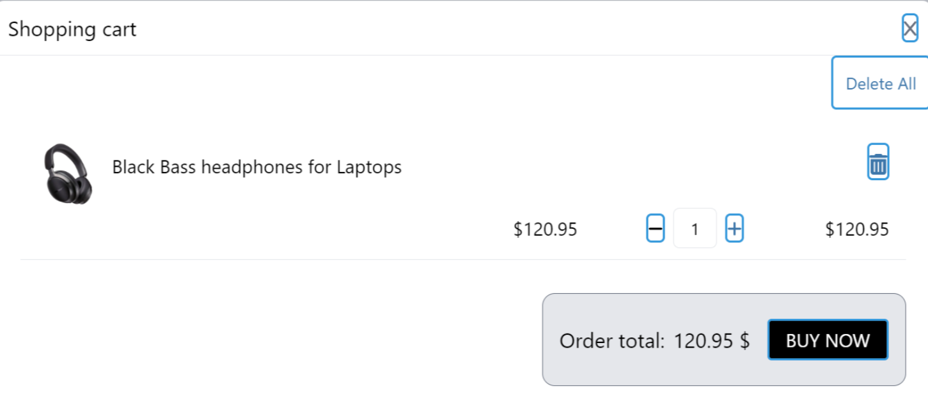

1. **FILTER**

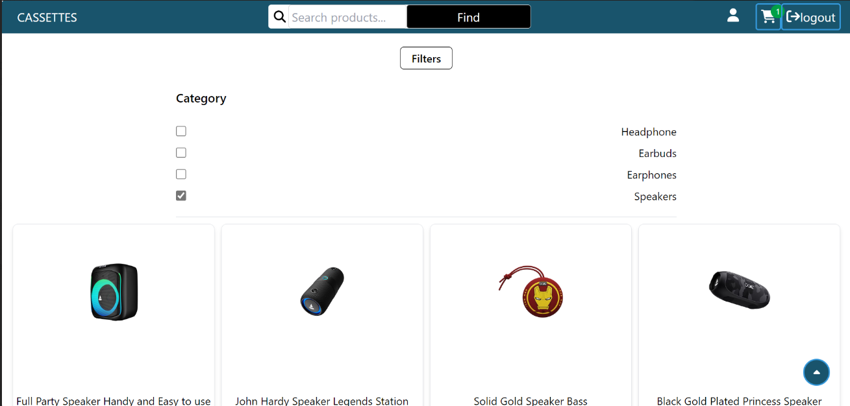

1. **BILLING/ CHECKOUT PAGE**

